FRONT COVER:

Terms and Conditions

LEGAL NOTICE

The Publisher has strived to be as accurate and complete as possible in the creation of this report, notwithstanding the fact that he does not warrant or represent at any time that the contents within are accurate due to the rapidly changing nature of the Internet.

While all attempts have been made to verify information provided in this publication, the Publisher assumes no responsibility for errors, omissions, or contrary interpretation of the subject matter herein. Any perceived slights of specific persons, peoples, or organizations are unintentional.

In practical advice books, like anything else in life, there are no guarantees of income made. Readers are cautioned to reply on their own judgment about their individual circumstances to act accordingly.

This book is not intended for use as a source of legal, business, accounting or financial advice. All readers are advised to seek services of competent professionals in legal, business, accounting and finance fields.

You are encouraged to print this book for easy reading.

Table Of Contents
Foreword

Chapter 1:
Wiseness

Chapter 2:
Beliefs

Chapter 3:
Love

Chapter 4:
How To Connect With The Temporal

Wrapping Up

Foreword

For centuries, spiritual precepts have pointed us to the heart and soul as the source of wisdom, truth, peace, and eternal life. We call it the heart and soul because these deeper realities are felt most strongly in the region of the physical heart.

But, the spiritual heart and soul isn't limited to a location in your body. The heart and soul is the totality of your connection with the crucial qualities and greater dimensions of your true nature as limitless existence. Any full exploration of the bigger truth of your existence must include a discovery of the capabilities and qualities of this tender, loving, and wise aspect of your true nature is a pointing beyond the experience of the Heart and its wisdom, peace, and love to the possibility of acknowledging these essential qualities as who and what you are.

The heart and soul with all its joy, satisfaction, peace, love, and wisdom isn't simply something you may experience more totally; it's what you've always been and always will be. In realizing your true nature as this fullness of existence, you may ultimately rest from worry about worldly possessions.

Eternal Life and You
Nourish your soul for all things eternal and reduce your attachment to all things temporal.

Chapter 1:
Wiseness

Synopsis

The truth opens up the heart and soul. This capability to sense the truth is something we all already bear. We all have a heart and soul that's already precisely showing us how true matters are.

Anything that places you in touch with more of the reality opens up the connection to the spiritual. Once your experience is imparting more truth, there's a sense of opening up, softening, easiness, enlargement, fulfillment, and gratification …


Connecting With Self Instead Of Stuff

This may be most directly felt in the core of the chest, but the heart and soul of all existence is infinite and consequently in reality bigger than your whole body.

So this opening up, softening, and enlargement is in reality happening everyplace; we simply sense it most clearly and directly in the core of the chest.

Once you meet truth, the sense of your self opens up, enlarges, softens, fills out, and relinquishes. The sense of your world is no longer felt to be so confined or little. It gets to be more complete and limitless. The limits soften and fade away, and any sense of deficiency, limit, or deficiency is decreased or annihilated.

As a side effect of becoming in touch with more of the truth, your brain gets quieter as you merely have less to consider. Even acknowledging a simple truth like where your keys are provides you less to consider.

And once you touch on a real big truth, your brain becomes even stiller, like once you view the sea for the first time: The reality or truth you’re looking at is so vast that at least for a minute your brain is stopped and gets really quiet.

In direct contrast, once your experience is getting into a decreased or smaller experience of the reality and of truth, the heart and soul narrows.

The sense of your world becomes tight, firm, compressed, and feels incomplete, limited, and restricted. It may feel like you're little, inadequate, or despicable.
The smallness of the reality is reflected in the littleness of the sense of your world. The result of being less in touch with reality is that your brain gets busier as it attempts to work out what is real.

As luck would have it, your existence is never belittled or contracted, only the sense of your self. Even as cutting your view of the whole room by partly covering up your eyes makes your sensation of the room littler without really making the room littler, an thought or notion that’s not really true is mused in a small sense of your self, without really limiting or condensing your existence.

Drill: Take a minute to sense your heart and soul. This may help you get more in touch with what is occurring there. Mark if the heart and soul feels comparatively compressed or comparatively open. In either event, your heart and soul is working absolutely to show you the degree of truth you’re getting in this instant. There's no wrong way for your heart and soul to react. It’s forever showing you the relative truth of this instant.

Truth is what subsists, what is current now. So, if what subsists is likewise what’s true, then there's only truth. Whatever is current is true—but to variable degrees.

Just as there's no actual matter or energy that's darkness, but simply altering amounts of the power of light, there's no untruth or falsity, only changing degrees of the truth.

Our heart and soul openness or lack or receptivity in every instant is what shows us how much of the truth is being received in any minute.

What about ideas that are misguided? If you entertain the thought that you’ll never be content unless you have 1 million dollars, your heart and soul will contract fittingly to show you that it’s simply an idea. This contraction might be really quick, so quick that it doesn’t cause you any irritation or hassle. But if you truly feel this, then the sense of your self-command condense for as long as that thought is held.

Drill: For just a minute, hold onto a confining idea like, “I'll never have adequate time” and note the response. Does this idea let you relax and be, or does it call for a sort of effort or compression simply to hold it? Now think about a different thought that you find absurd as it’s so untrue like, “I'll never be happy unless I become president of Microsoft.” Note how it may even be inconceivable to hold onto this idea. It may even make you laugh.

Many confining ideas are true, but only as ideas. As these ideas subsist, they've some reality to them, but the existence of something simply as an idea is a really small existence indeed.

In the range of daily experience, our thoughts have variable degrees of correspondence with truth. Those that agree more closely to reality won’t constrict or limit the sense of self for as long as erred ones.

Chapter 2:
Beliefs

Synopsis

A lot of beliefs and suppositions shape and limit our experience of life and connecting and the sense of our self even when we’re not consciously considering them. They're thoughts and concepts that are so deeply trusted that they’re not even questioned, like “life is short” or “I have to have more money.” Moreover, these notions and assumptions render other thoughts, which add to the momentum of thinking and keep your heart and soul, the sensation of your self, little and compressed.
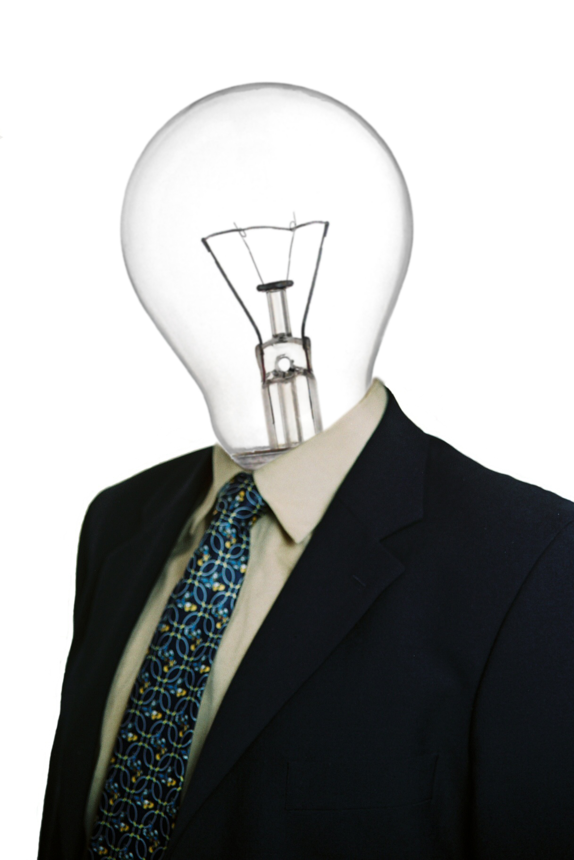

How We Think

Beliefs strongly shape the experience of your world. The first is the belief in a management to your life. Commonly this management is towards more, dissimilar, or better experiences; but occasionally it’s framed in contrary terms as not less, equal, or not sorrier.

In either event, there’s a profoundly held notion that life ought to move or shift in a specific way. Naturally, things do shift, which keeps the hope alive that they'll change in the way you wish them to.

This profoundly held assumption that matters may or ought to be better connotes a little you. The directivity of this assumption is based on a point of reference: matters ought to be better—for you.

If matters ought to be better for you, then you have to be lacking something. This supposition and the thinking it returns help maintain a little, compressed sense of your world as that's the implied point of reference of the presumption—a small you.

The 2d even more bass and less witting belief that serves to maintain a compressed sense of self is the presumption that physical experience is the most genuine. This is such a widely held supposition that any other predilection may get you pronounced demented.

Even really sensitive and spiritually-oriented individuals who have had really true and profound experiences of additional dimensions are frequently pulled by this premise back toward the physical into a more confined experience of reality.

There are a lot of dimensions to truth besides the strictly physical, and as a human, your experience admits all of these dimensions. There are the dimensions of ideas, emotion, and hunch. And on the far side of those, are dimensions of complete presence.

A lot of these dimensions are more actual than even physical truth. Experiences of this surpassing reality provide a surpassing sense of your self that's much broader and more perfect than the strictly physical sense of your self.

These 2 beliefs—the principle that your life may or ought to be better and the thought that physical truth is the most actual—vivify an even more basic supposition: that you're the core of reality.

Your sense of your world, and consequently the experience of your existence, is most frequently shaped and limited by your identification with the core of reality, which results in the ongoing question, how is it going for the core of reality? Is it better, more enjoyable, or leastways not painful right now?

This orientation towards the core of reality is not bad, but it’s a limited way of feeling reality and your world. It’s like seeing only one channel on your TV: It’s something, but it’s confined.

This limitation may impact each experience you get. By centering on how it’s going for your core of reality, you may miss some of the richest and most fundamental possibilities in life. The largest truths might not even be particularly well-situated for your core of reality. Profound states of love and blissfulness may be wearing from a purely physical position.

Inquiring what you may do about this limitation will only reward it. A different hypothesis is to explore the sense of restriction that identification with the core of reality gives to your awareness and your heart and soul.

Drill: What is it like to trust you're the core of reality right now? Does this let your gist open and relax? Or does it lead to a small sense of your self? With the credit of the incompleteness of identifying with the core of reality, a bigger curiosity often comes up: What else is real about you? Are you more than the core of reality? What additional channels are there on this TV called your life story? What else is happening here?

Under the assumption that you're the core of reality is an even deeper one. The idea that you're the core of reality is predicated on the presumption that you exist, that you are a self—a separated, individual self.

The most familiar sense of your self is frequently this sense of me, which is a confined and incomplete perception of your self. It doesn’t let in the far reaches of your greater equaling. This sense of a disjoined me isn't bad or wrong; it’s simply confined and incomplete.

In the middle of a really profound and big experience of reality, the sense of your self may get so big and inclusive that it no longer has much of a sense of being your existence.

Once you wake up to the unity of all things, the sense of me may reduce quite dramatically. If you're the couch you're sitting on and the clouds in the sky and everything else, then it merely doesn’t add up to call it all me. If it’s a great deal more than what you commonly take yourself to be, then the term me is simply too little.

What is your sense of self like today? What is true today?



This preview copy ends here and to get the full product, please go to (the website URL ) here to get the full product.

